Artist Statement

I have always been drawn to art as if it was an inherent part of me. It gives me pleasure, satisfaction, and a freedom of expression and declaration.

Recently returning to painting after a thirty-year career as a professional graphic designer, I sought out the subject that most intrigued and interested me: portraiture.
Everyone is unique. Beyond representing a person’s likeness on canvas, my ultimate objective is to find and portray their driving force. I want to convey the innermost essence, the individuality, and the spirit of every subject I paint. The end goal is that every viewer of my work sees the person beyond the image on the canvas.

I am mainly influenced by the portrait artists and illustrators that lived around the turn of the 20th century. John Singer Sargent, Joaquin Sorolla, Anders Zorn, James McNeill Whistler, William Merritt Chase, Howard Pyle and N.C. Wyeth are some of my greatest sources of inspiration. Their art continually serves as encouragement for excellence and growth in my work.

I am a draughtsman and use drawing as a cornerstone of my painting. This aptly classifies me as a realist. I am also greatly influenced by color and constantly infuse it within my portraits, often pushing it to its limits. Discovering colors that best represent the essence of my subjects coupled with my drawing skills provides me with the vision and approach to a successful painting. I often work in other mediums but prefer painting with oils as my medium of choice. Oils are lush and bold. They give me the perfect vehicle to complete the statements in portraiture that I seek.

This is the energy that makes portraiture alive for me, which in turn, gives me the passion, drive, and will to paint.

Bill Mapes was born in Philadelphia and spent most of his growing years along the sandy beaches of the Cape May, South Jersey area. He graduated from the Philadelphia College of Art (now the College of the Arts) in 1971 with a BFA in Illustration. Bill studied under Ben Eisenstat, Sidney Goodman, Edna Andrade, Jane Piper, Al Gold, Isa Barnett, and Steve Tarantel. He won national recognition in an annual Print Magazine cover design competition.
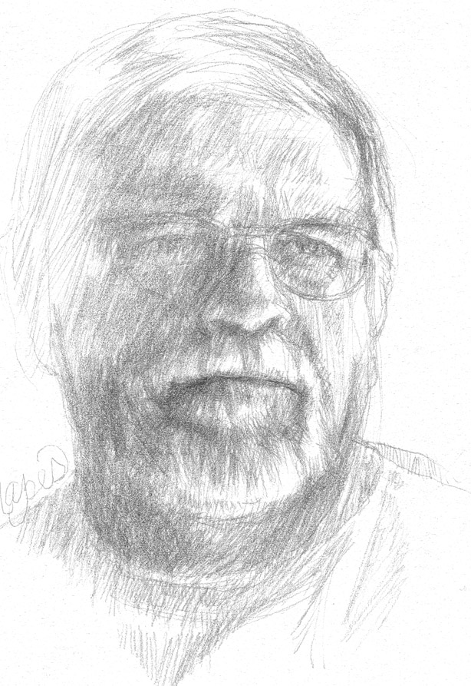
Self-Portrait - Silverpoint
Bill spent 35 years in the commercial art field in the Washington, DC region, 30 of those years as a freelance illustrator/designer. During that period, he taught a University of Maryland University College Adult Education course in Graphic Fundamentals for several years.

Bill has returned to his love of oil painting and fine art. Having a deep passion for history, particularly the mid-1860’s Civil War era, provides him with a unique perspective on historical painting and portraiture. Being an avid outdoorsman, Bill continues to paint the landscapes of Maryland throughout the year. Working in graphite mediums, particularly charcoal and pencil, he specializes in figurative drawing and composition.

A certified member of the Maryland Society of Portrait Painters, Gaithersburg Fine Art Association and past two-term President and lifetime member of the Art League of Germantown.

Bill has exhibited throughout Montgomery County venues including VisArts of Rockville, Glenview Mansion Gallery, the Art League of Germantown’s and the Gaithersburg Fine Artist Association’s Annual Juried Art Exhibitions at the Kentlands Mansion and the Maryland Society of Portrait Painters juried exhibits throughout Maryland.

Bill’s portrait of “Clara Barton” is part of the permanent collection at the Clara Barton Historical Site, Glen Echo, Maryland. The portrait is on display in the Clara Barton Historical Site gift shop.

Bill also painted a portrait commission of City Councilman Julius J. Persensky for the City of Gaithersburg.

williammapes@comcast.net
301-963-4675

